Statement of Work
Counter Mobile Application for Android

Summary
Type of Service: Mobile Development for Android
Contract Start Date: TBD
Contract End Date: TBD

The Project
Development of Mobile Application for Android Platform. This application will enable bus drives to perform passenger count.

Deliverables and Acceptance Criteria
AD communication will produce Mobile Application for Android that will consists of the following screens:

Screen 1: Login Screen  Objects:  Username text box (drop down list), Password text box, Exit Button, Login Button, Online status indicator  Functions:  Exit button will close this application.  Login button will authenticate user credentials against locally store user database.  Password is an optional filed (it could be left blank).  User name textbox could become a dropdown list based on server configuration. (Passed from web service)  If user fails to provide valid credentials “Can’t sign in” Error message will pop up.  Comments:  Questions: | 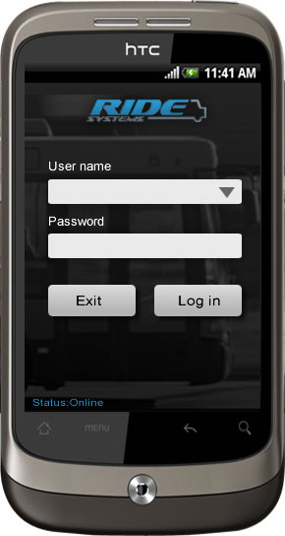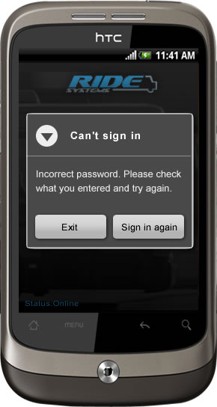
Screen 1: Login Screen  Functions:  In an event application does not have initial database downloaded. (Application status is offline)  Or application is in the process of downloading.  And User is trying to sign in. Detailed Error message will be displayed.  Comments:  Questions: | 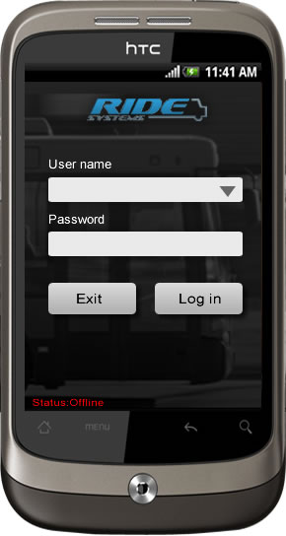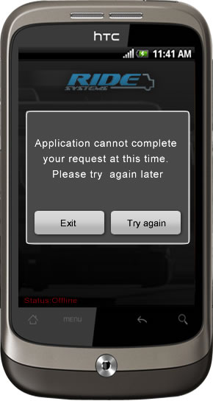
Screen 1: Select Route Screen  Objects:  Logo and Screen name will appear at the top of the screen. Driver Login, Route and Vehicle drop down boxes.  Functions:  User will have an option to select route and vehicle from drop down. (Information will be pulled from local storage)  If user will press start button without selecting vehicle or route, detail error message will appear  Comments:  Questions: | 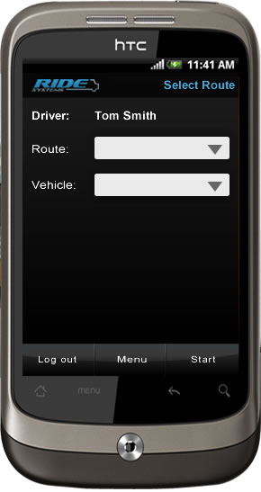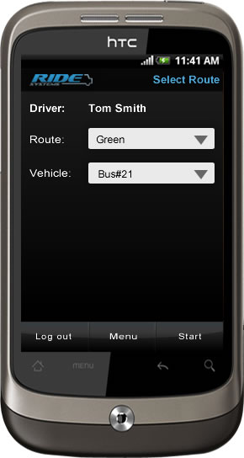
Screen 1: Passenger Count Screen  Objects:  Logo and screen name at the top of the screen.  Count main category, and up to 3 subcategories with “-” and “+” buttons next to them. Stop name, Additional top-level count categories. Bus name and rout name.  Functions:  User will be able to add/remove count for selected category, subcategory using “+” and “-“ button.  Comments:  Questions: | 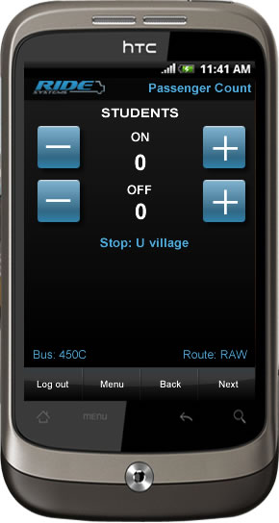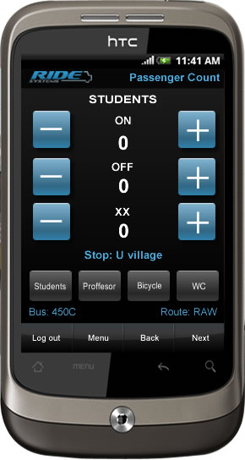
Screen 1: Passenger Count  Objects:  Logo, Screen name, Stop, Bus, Route, Count category, numerical keypad  Functions:  This screen will allow driver to input count of the single category and single subcategory only.  Comments:  Questions: | 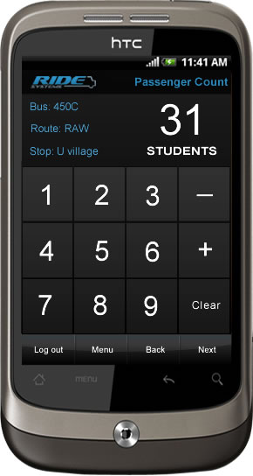
Screen 1: Summary – End of Route  Objects:  Functions:  This screen appears at the end of the route and contains totals of all counts across all available categories. User have ability to correct any numbers on this screen  Comments:  Questions:  How are corrections recorded (as we have detailed info per stop) and communicated to the server? | 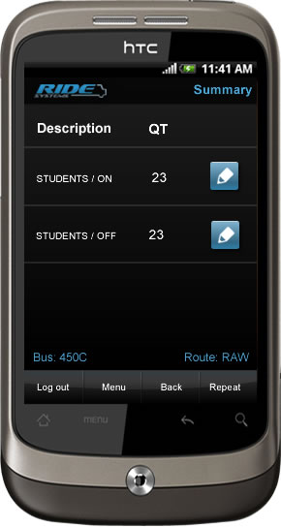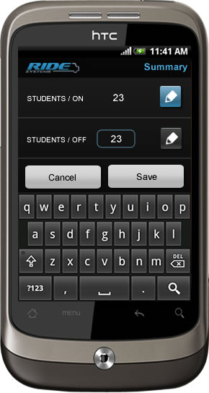
Screen 2: Menu  Objects:  Functions:  Comments:  Questions: | 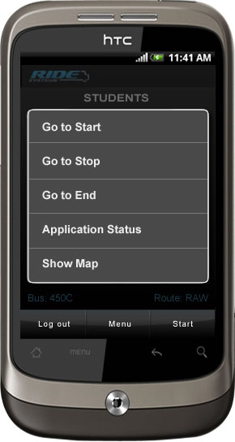
Screen 3: Stop Selection – Go To Stop  Objects: Logo, Screen Name, List of Stops for the route, Bus name, Route Name.  Functions:  This screen contains list of the routes. User will have ability to jump to the selected stop.  Comments:  Questions: | 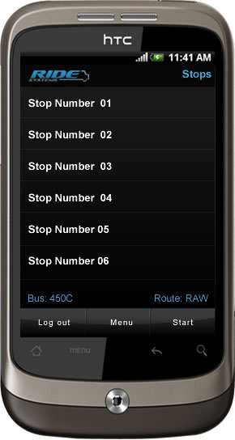

Authentication

Offline storage and Syncronization

Web Service
http://www.ridesystems.net/RideServices1_2/RideWCFService.svc

Configurations
Following parameters should be configurable on a device:

Web Service URL
Web Service Credentials (Optional)
Client Token
Login Requirements
Number of days to keep comments
Internet enabled
Client website

Ability to configure audio effects for the following user actions:
Plus button pressed
Minus button pressed
Clear button pressed
Numeric button pressed

Distribution
This application will be distributed as an “apk” file.
(Due to specific audience fo this application it won’t be distributed over the Marketplace)

Supported operating systems:
Application should perform as expected on: Android 2.1 and above; including Android 3 on tablet devices.

Screen Resolution:
Screen resolution will vary per device. Application should be smart enough to adjust to each screen size. Application should perform as expected on Tablet devices.

Appendix

Config File(Presently in use)
<Settings>
<Sync_Settings>
<!--<Sync_URL>http://ben-dae2e41767f:1175/RideWCFService.svc</Sync_URL>-->
<Sync_URL>http://www.ridesystems.net/RideServices1_2/RideWCFService.svc</Sync_URL>
<Authentication>
<Employee_ID>1</Employee_ID>
<Company_ID>5</Company_ID>
<Token>OUMedical1</Token>
</Authentication>
</Sync_Settings>
<Program_Settings>
<Require_Login>false</Require_Login>
<Audio_Files_Directory>[Root]\AudioFiles</Audio_Files_Directory>
<Web_Map_URL>http://ridesystems.net/RideSystemsAdmin/MapFeedback/Map_Feedback.html</Web_Map_URL>
<Plus_Press_Wav_File>[Root]\Resources\add.wav</Plus_Press_Wav_File>
<Minus_Press_Wav_File>[Root]\Resources\minus.wav</Minus_Press_Wav_File>
<Clear_Press_Wav_File>[Root]\Resources\numclick.wav</Clear_Press_Wav_File>
<Numeric_Press_Wav_File>[Root]\Resources\numclick.wav</Numeric_Press_Wav_File>
<Database_Definition_Location>[Root]\Database\Database.xml</Database_Definition_Location>
<Days_To_Keep_Handheld_Comments>1</Days_To_Keep_Handheld_Comments>
<Max_Previous_DVIR_Days>15</Max_Previous_DVIR_Days> - keep data on the device
<Space_Between_Route_Criteria_Controls>10</Space_Between_Route_Criteria_Controls>
<Wireless_Enabled>true</Wireless_Enabled>
<Company_Base_URL>http://www.oumcexpress.com</Company_Base_URL>
<Require_GPS_Gate_For_Vehicle_Route>true</Require_GPS_Gate_For_Vehicle_Route> - software installed on this device
</Program_Settings>
<Database_Settings>
<File_Name>[Root]\Database\Ride.sdf</File_Name>
</Database_Settings>
<Ping_Settings>
<!--<IP_Address>216.139.213.27</IP_Address>-->
<IP_Address>http://www.ridesystems.net/</IP_Address>
<Seconds_Interval>10</Seconds_Interval>
</Ping_Settings>
<GPS_Settings> - GPS integration
<Com_Port>1</Com_Port>
<Baud_Rate>0</Baud_Rate>
<Seconds_Interval>10</Seconds_Interval>
</GPS_Settings>
</Settings>

Web Service Definitions(WSDL)
URL:

